**XAVIER UNIVERSITY – ATENEO DE CAGAYAN**

**COLLEGE OF COMPUTER STUDIES**

**DEPARTMENT OF INFORMATION SYSTEMS**

|  |
| --- |
|  |
|  |  |

**HubIT**

A Project Presented to the Faculty of the

Department of Computer Science

College of Computer Studies

In Partial Fulfillment of the Requirement for the Course

CC 14 – Database System and Information Management

by:

Sean Myko C. Baang

Gecel Bonn G. Rodriguez

CC 14-D

September 30, 2019

**Case Description: hubIT**

**General Description:**

hubIT serves as a open forum for programming beginners that allows them to straightforwardly share and browse topics/files. hubIT also serves as a platform for users to share their own topics and files towards other users.

**Basic Operations:**

Users usually use this application to upload source codes/Books/PDFs and share it with other users. If there are source codes or books/PDFs shared, the users can download the files. This application can only be used in computers. All shared files are sent to the database. Each file can be categorized by their file formats, topic type, and date uploaded which allows the user to find the file they needed with ease. A file can be uploaded/downloaded in public or in rooms.

To use the application, they are required to sign-up to register their account which they need to input their personal information such as their Full Name, E-Mail, Password, Birth date, Gender, Address, and their Occupation.

**Information Needs:**

All user data are to be stored in the central database. The developers are responsible for the stored credentials of the user.

1. **User Registration/Verification:** User ID, e-Mail, First Name, Last Name, Password, Birth Date, Gender, Occupation, Address, and Reputation

Allows the user to verify his/herself to log in to the system.

1. **Topic:** Topic ID, Topic Title, Topic Type, Topic Date

This filters file categories to ease finding of file types.

1. **Category:** Category ID, Category Description, and Category Type

This filters category based on user preference.

1. **Upload/Download/View files :** File ID, File Name, File Type, and File Date.

This allows the user to upload, download, or view files. Can upload, download, view files by filename, file type, or date uploaded.

1. **Manager:** Manager ID, Manager Username, and Manager Password.

This manages the files uploaded and the topic created by the users. Can also manage users information.

**Users’ Requirement Specification**

The Hub IT database keeps track of users, categories, uploaded files, and topics.

The application is controlled by users and each user has a unique id, a first name, last name, username, user email, user password, user birth date, user gender, and user occupation which are required for user identification.

A category filters items, each of which has a unique id, category description, and category type.

A Topic contains items such as files, text, etc. Each of which has a unique id and topic description. A topic can be created by a user and can be viewed by multiple users. We keep track of the user that created the topic. We also keep track of the category of the topic.

A file is uploaded by one user but can be downloaded by multiple users. Each file is stored with its unique id, file name, file type, and file data. The file’s uploader can be identified of whoever uploaded the file and it can also be sorted according to its proper category.

**Conceptual Data Model**

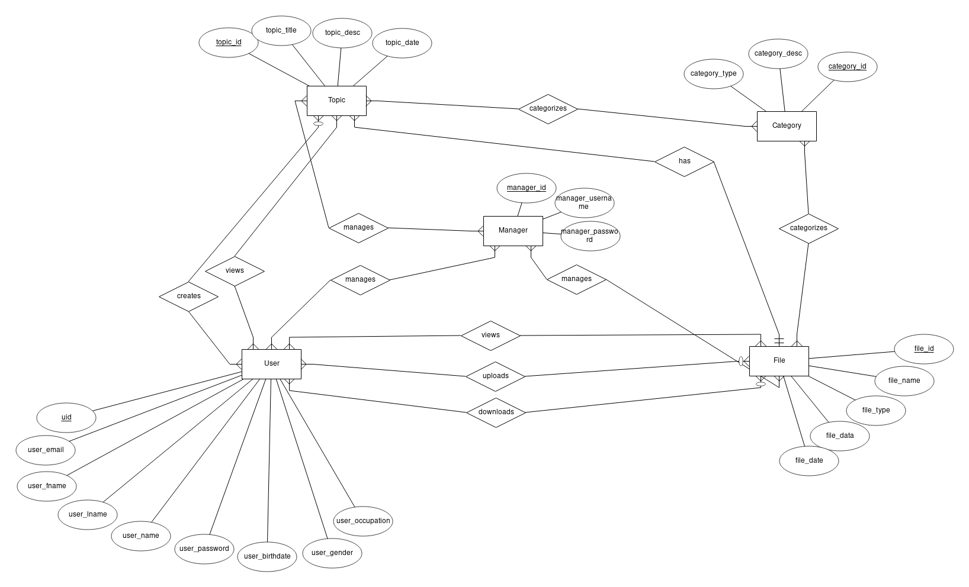

**Logical Data Model**

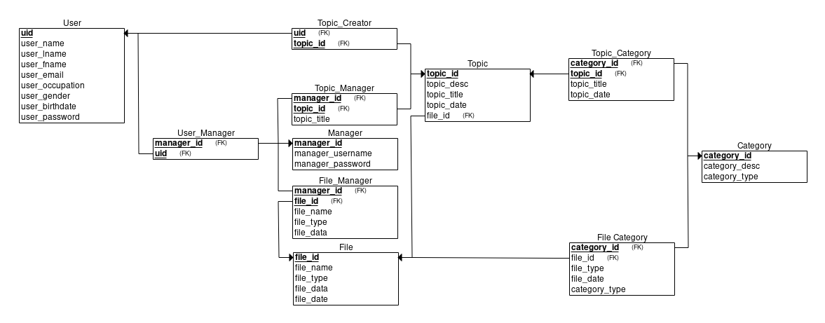

**Data Dictionary**

|  |  |  |  |  |  |  |  |  |
| --- | --- | --- | --- | --- | --- | --- | --- | --- |
| **Table Name** | **Attribute Names** | **Contents** | **Type** | **Format** | **Range** | **Required** | **PK** or **FK** | **FK Reference Table** |
| User | uid  user_name  user_fname  user_lname  user_email  user_occupation  user_gender  user_birthdate  user_password | User Account ID Number  Username  User First Name  User Last Name  User Email  User Occupation  User Gender  User Birthdate  User Password | INT  VCHAR(11)  VCHAR(30)  VCHAR(30)  VCHAR(50)  VCHAR(50)  VCHAR(10)  DATE  VCHAR(50) | 99999999999  Xxxxxx  Xxxxxx  Xxxxxx  Xxxxxx  Xxxxxx  Xxxxxx  Yyyy-mm-dd  xxxxxx | 1-99999999999 | Y  Y  Y  Y  Y  Y  Y  Y  Y | PK |  |
| Category | category_id  category_desc  category_type | Category ID number  Category Description  Type of Category | INT  VCHAR  (255)  VCHAR(30) | 99999999999  Xxxxxx  Xxxxxx | 1-99999999999 | Y  Y  Y | PK |  |
| File | file_id  file_name  file_type  file_data  file_date | File ID Number  File Name  Type of File  File Content  Date of File | INT  VCHAR(50)  VCHAR(20)  VBINARY  (4096)  DATE | 99999999999  Xxxxxx  Xxxxxx  Yyyy-mm-dd | 1-99999999999 | Y  Y  Y  Y  Y | PK |  |
| Topic | topic_id  topic_title  topic_desc  topic_type  topic_date | Topic ID Number  Topic Title  Topic Description  Topic Type  Date of Topic | INT  VCHAR(50)  VCHAR  (255)  VCHAR(30)  DATE | 99999999999  Xxxxxx  Xxxxxx  Xxxxxx  Yyyy-mm-dd | 1-99999999999 | Y  Y  Y  Y  Y | PK |  |
| Manager | manager_id  manager_username  manager_password | Manager ID  Username of Manager  Password of Manager | INT  VCHAR(11)  VCHAR(50) | 99999999999  Xxxxxx  Xxxxxx | 1-99999999999 | Y  Y  Y | PK |  |